Environment

📘 Definition
# Source: AI Source: Provided by: [Data Path: Persons Table -> ID Column: 1, Name_En Column: Motasem Essam] -> From: [ChatGPT] on [5/2/2026]
An environment is the surrounding scene or space in which objects exist and interact in a computer-generated world. It includes everything that forms the background and setting of a 3D scene.

🌍 What an environment includes
# Source: AI Source: Provided by: [Data Path: Persons Table -> ID Column: 1, Name_En Column: Motasem Essam] -> From: [ChatGPT] on [5/2/2026]
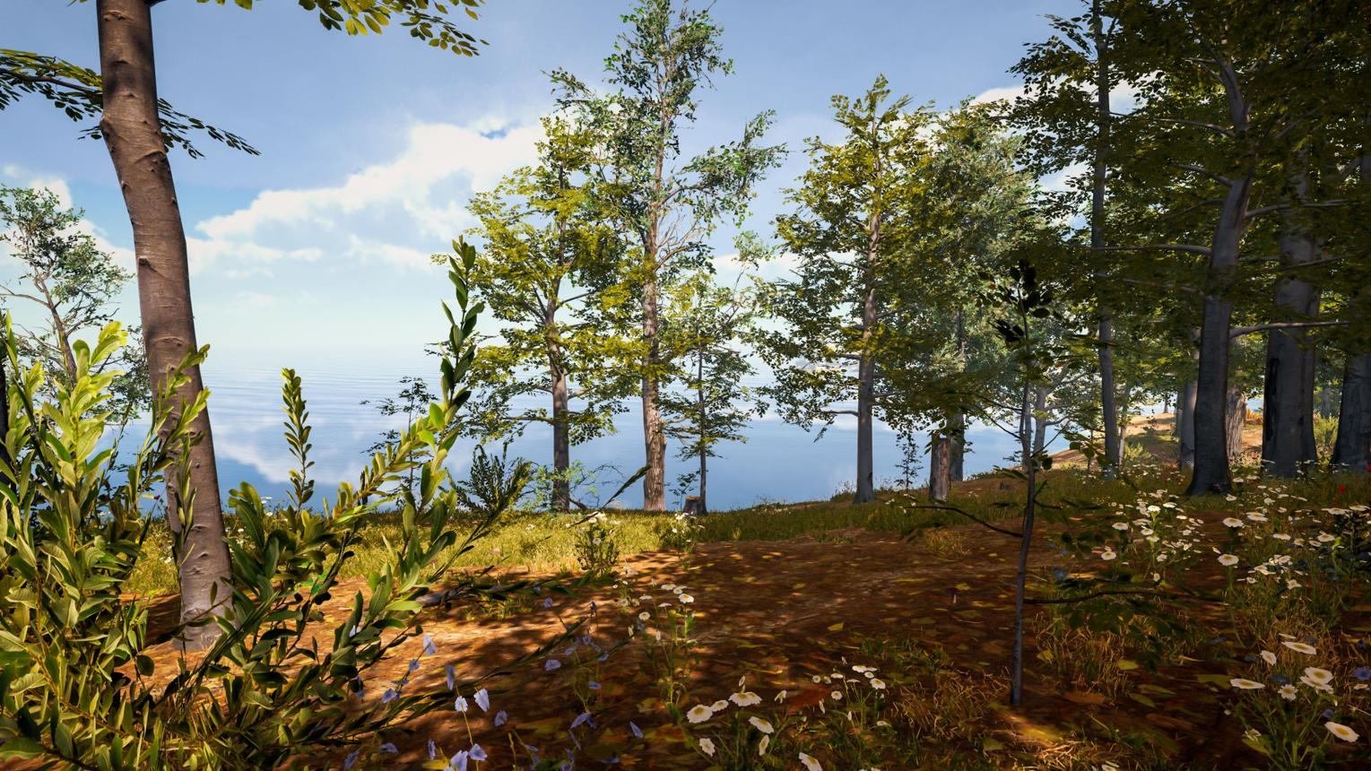
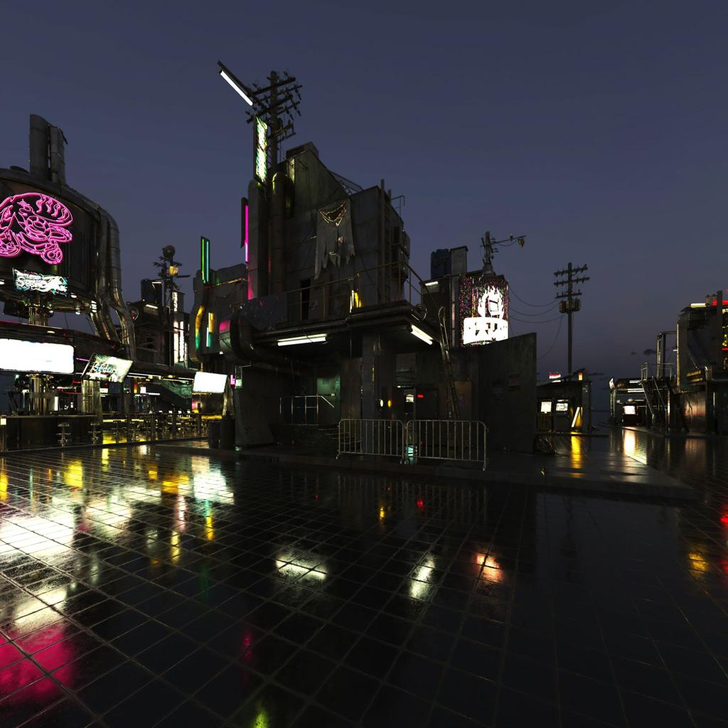
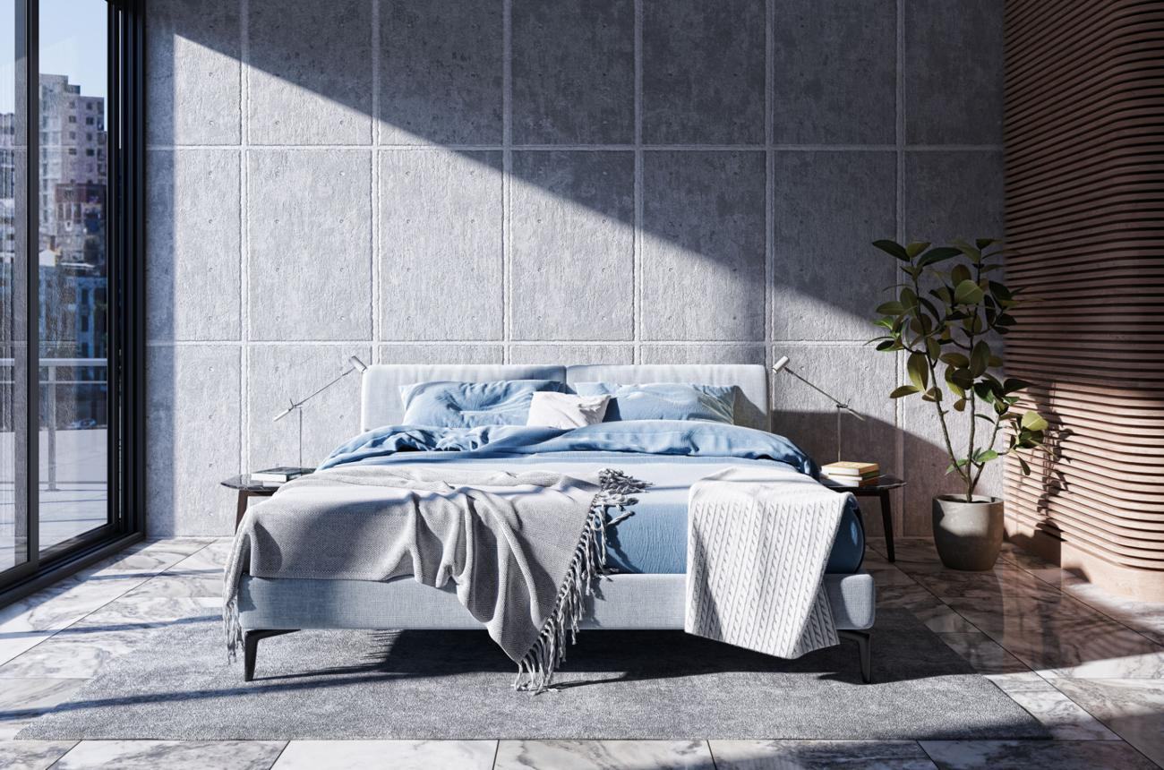
A 3D environment can include:
- 🌳 Natural elements → trees, mountains, rivers
- 🏢 Man-made elements → buildings, roads, furniture
- ☀️ Lighting → sun, lamps, ambient light
- 🌌 Background → sky, fog, atmosphere
- 🎮 Objects → characters, vehicles, items

🧠 Simple example
# Source: AI Source: Provided by: [Data Path: Persons Table -> ID Column: 1, Name_En Column: Motasem Essam] -> From: [ChatGPT] on [5/2/2026]
Think of:
- 🎮 A video game map (forest, city, desert)
- 🎬 A movie scene background
- 🏠 A virtual room in a 3D design
Everything around the main object is part of the environment.

🎮 Environment in computer graphics
# Source: AI Source: Provided by: [Data Path: Persons Table -> ID Column: 1, Name_En Column: Motasem Essam] -> From: [ChatGPT] on [5/2/2026]
Environments are used to:
- Create realistic worlds in games and movies
- Provide context for objects and characters
- Improve immersion and visual experience
- Simulate real-world or imaginary spaces

⚙️ Key features
# Source: AI Source: Provided by: [Data Path: Persons Table -> ID Column: 1, Name_En Column: Motasem Essam] -> From: [ChatGPT] on [5/2/2026]
- 🌍 Includes everything around objects
- 🎨 Combines models, lighting, textures, and atmosphere
- 🎮 Essential for games and animation
- 🧩 Makes scenes feel realistic and complete

🚀 In short:
# Source: AI Source: Provided by: [Data Path: Persons Table -> ID Column: 1, Name_En Column: Motasem Essam] -> From: [ChatGPT] on [5/2/2026]
Environment = the complete surrounding scene in a 3D world where objects, lighting, and background exist together.

